SMARTER CAMPAIGN TARGETING
Predictive Analytics for Cohort 8 Banking Campaign
A Smarter Way of Banking
Table of Contents
1. Project Overview 3
2. Problem Statement 3
3. Objectives / Tasks 4
3.1 Exploration 4
A. Previewing and Data Collection: Data: 4
3.2 Data Preprocessing 4
3.3 Exploratory Data Analysis (EDA): 4
A. Univariate Analysis 4
i. Numerical Data Types: Distribution and Outliers Numerical Variables: 4
ii. Categorical Data Types: 5
B. Bivariate Analysis 6
iii. Numerical vs Categorical (Target: Term Deposit): 6
iv. Numerical vs Numerical: 7
v. Categorical vs Categorical: 8
C. Summary of Exploratory Data Analysis (EDA): 9
4. Feature Engineering 9
A. One-hot encoding 9
B. Scaling: 9
C. Splitting the data to train and test 9
D. Using SMOTE 9
E. Models Selection: 9
F. Models tuning: Hyperparameter tuning 10
Observations: 10
G. Top Predictors: 11
5. Business Insights & Recommendations 12
A. Prioritize Call Quality Over Quantity 12
B. Retarget Past Converters 12
C. Time Campaigns Strategically 12
D. Focus on High-Balance Clients 12
E. Enhance Data Collection 12
F. Align Messaging with Client Segments 13
6. Dashboard Deployment 13
A. Purpose 13
B. Key Benefits 13
C. Functionalities 13
7. Challenges: Failure of Dashboard 15
8. Conclusion 16
9. Appendix 17
A. Data Dictionary 17
B. Modeling Results 18
C. Evaluation Metrics Explained 18
D. Dashboard Batch Upload Template 19
E. Sample Upload Template 19
F. Sample of Predicted output 19
G. Step-by-Step Guide 19

Project Overview
Cohort 8 Banking aims to enhance its marketing effectiveness using AI and machine learning. The goal is to build a model that predicts which clients are most likely to subscribe to term deposits, allowing the marketing team to target campaigns more strategically. This project uses past campaign data (45,211 records) (See Appendix A: Data Dictionary) to train predictive models and extract actionable insights.
Key Deliverables:
- XGBoost model with 90% accuracy and 92.3% ROC AUC.
- Actionable insights (e.g., call quality > frequency).
- Interactive dashboard for marketing teams.
Impact:
- higher conversion rates.
- reduction in wasted outreach costs.

Problem Statement
Cohort 8 Banking currently uses only basic data analysis. Traditional marketing often involve contacting large numbers of clients without knowing who is likely to respond. This leads to wasted effort and increased costs. The bank seeks a predictive solution that enables them to focus on clients with high conversion potential.
Current Challenges:
- Static reports limit proactive decision-making.
- Low subscription rates due to untargeted campaigns.
- Over-contacting (e.g., >50 calls/client) reduces efficiency.

Solution: An AI system to:
- Predict subscription likelihood using behavioral and demographic features.
- Prioritize high-value clients (e.g., high balance, past converters).
- Optimize campaign timing (e.g., peak month: May).

Objectives / Tasks
My task as an AI Engineer is to enhance the existing system with predictive capabilities. Starting off with:

Exploration

Previewing and Data Collection: Data:
- Previewing the data
- Identify variables, missing values and their types (numerical, categorical, etc.)
- Check data dimensions

Data Preprocessing
- Missing values: There are no missing values.
- Renaming of columns for the convenience of better understanding.

Exploratory Data Analysis (EDA):

Univariate Analysis

Numerical Data Types: Distribution and Outliers Numerical Variables:
- Box plots for distribution and outliers using mean, median, mode, standard deviation, range, quartile.
(See figure 1: Fig1NumericalDataTypesDistributionandOutliers.png)
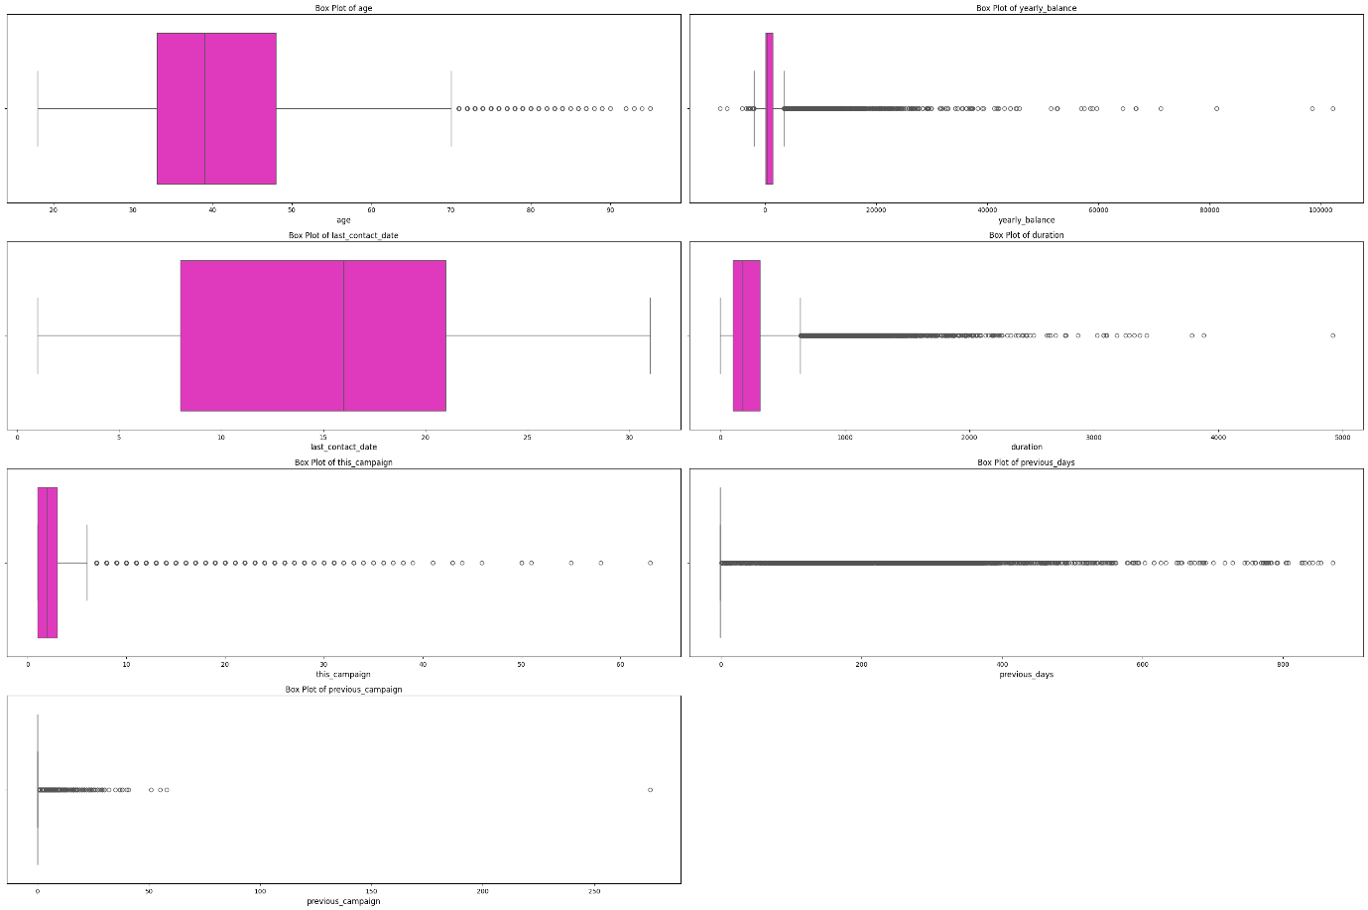
Observations:
- Most clients are aged between 30–60; a few older outliers are present.
- Yearly balance is heavily right-skewed; some clients hold extremely high balances.
- Call durations vary widely; subscribers tend to have longer conversations.
- Contact frequency is mostly 1–5 times per campaign; some exceed 50, raising concerns of over-contacting.
- Majority of clients were either never contacted or contacted recently; few had interactions over long gaps.
- Most clients had no previous campaign interactions.

Categorical Data Types:
- Frequency: Using pie charts for frequency visualizations
- Most Frequent: Mode identification (most frequent category) for descriptive analysis
(See figure 2: Fig2CategoricalDataTypesFrequency.png)
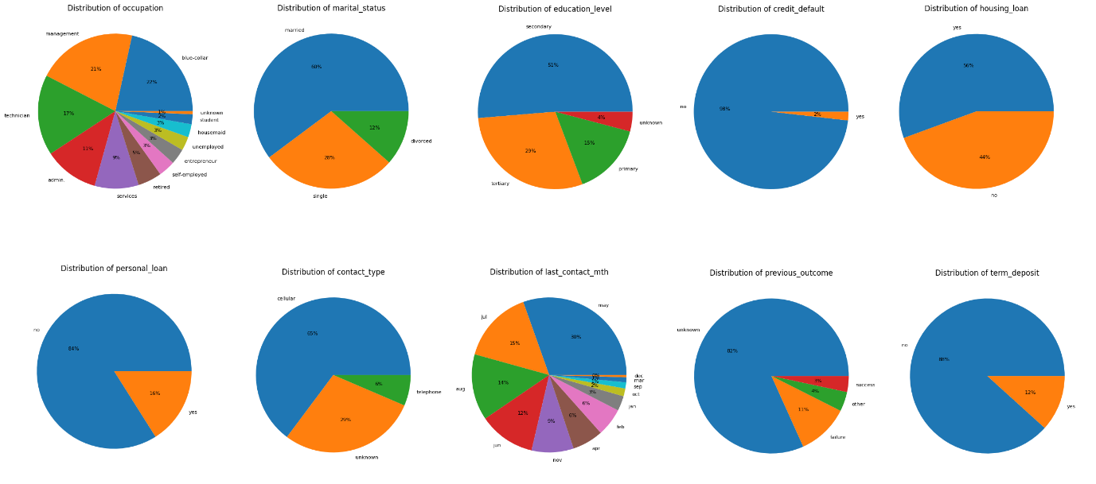
Observations:
- Common occupations: blue-collar, management, and technician.
- Most clients are married and have secondary education.
- Majority do not have personal or credit loans but often hold housing loans.
- Cellular is the dominant contact channel; May is the peak contact month.
- 82% of clients have no previous outcome history.
- Only 12% subscribed to term deposits, showing class imbalance. (Apply SMOTE)

Bivariate Analysis

Numerical vs Categorical (Target: Term Deposit):
- Bar plots measures the average numbers with the target ‘Term Deposit’
(See figure 3: Fig3NumericalvsCategoricalTargetTerm Deposit.png)
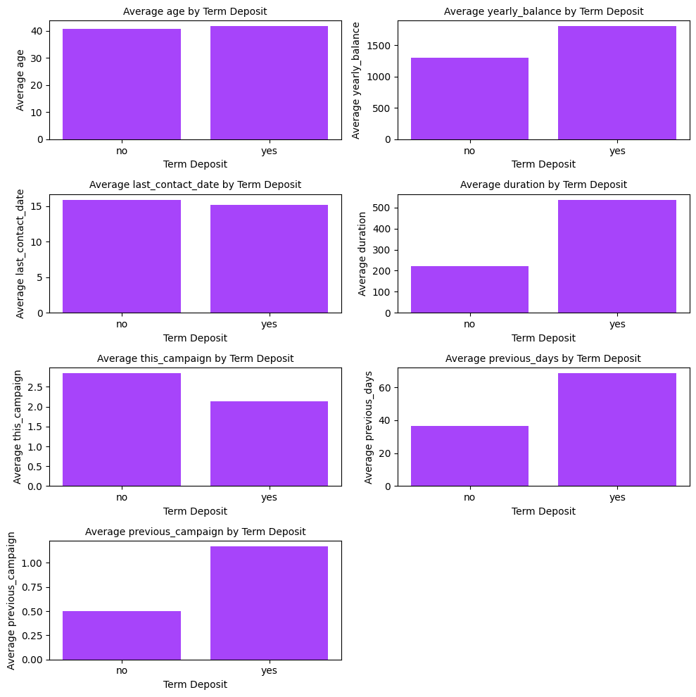
Observations:
- Subscribers are slightly older, wealthier, and more engaged (longer calls, fewer but more effective contacts).
- Past participation in campaigns and longer gaps between contacts are linked to higher conversion.
- Over-contacting may reduce subscription likelihood.

Numerical vs Numerical:
- Scatter plots for correlation visualization
(See figure 4: Fig4Numericalvsnumerical.png)
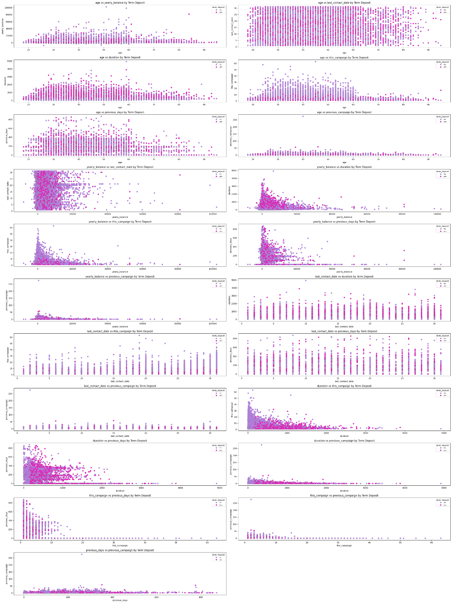

Observations:
- Scatter plots confirm: longer durations and higher balances are strong indicators of subscription.
- Age alone doesn’t predict subscription
- Clients with fewer contacts and longer call durations tend to subscribe more.

Categorical vs Categorical:
- Cramér’s V measures two categorical variables based on the Chi-squared test
    - Where: 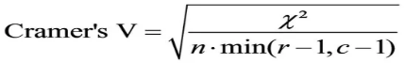
    - V = Cramer’s V coefficient
    - χ2 = Chi-square statistic from the chi-square test
    - n = Total number of observations
    - r = Number of rows in the contingency table
    - c = Number of columns in the contingency table
(See figure 5: Fig5CategoricalvsCategorical.png)
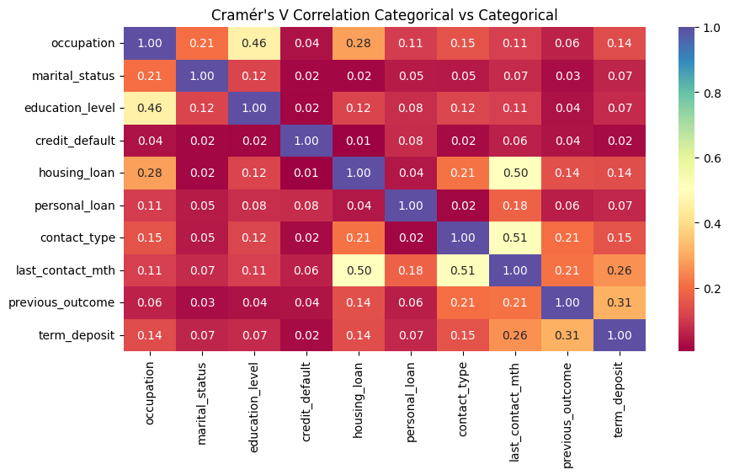

Observations:
- Strong link between contact type and last contact month (e.g., cellular used heavily in May).
- Education aligns moderately with occupation.
- Previous outcome moderately predicts subscription.
- Very weak associations for credit default, personal loan, and marital status.

Summary of Exploratory Data Analysis (EDA):
The analysis reveals that behavioral and engagement factors—particularly call duration, client balance, previous campaign interactions, and contact timing—are the strongest predictors of term deposit subscriptions. Subscribers exhibit longer call durations and higher conversion rates among high-balance clients. May’s campaigns outperform other months and clients with prior campaign engagement convert more often. However, class imbalance for subscriptions and other outliers in call duration exceed 30 minutes and disproportionate wealth. For modeling, using robust scaling to mitigate outlier effects.

Feature Engineering
- One-hot encoding for categorical columns.
- Scaling: Robust scaler due to high outliers (e.g in durations, yearly balance and previous days
- Splitting the data to train and test
- Using SMOTE to treat the class imbalances. Balance the data before modeling. Results: Name: count, dtype: int64
- Before SMOTE 0 = did not subscribe/1 = subscribers: term_deposit
0: 27945 1: 3702
- After SMOTE 0 = did not subscribe/1 = subscribers: term_deposit
0: 27945 1: 27945
**Experiment on Standard Scaler also shown the same results as Robust Scaler.
- Models Selection:
- Logistic Regression: a baseline model and easy to interpret
- Random Forest: Handles both numerical and categorical (one-hot encoded) data well. Robust to outliers (e.g., high balances, long durations) Gives feature importance which helps explain predictions
- XGBoost (Extreme Gradient Boosting): effective on structured tabular data. Built-in regularization avoids overfitting which is useful when data is imbalanced
- Artificial Neural Network (ANN): Adds a deep learning option to explore more complex relationships. Can model complex interactions between features. Best choice for structured/tabular data.
  - Input Layer: Takes in your features (e.g., age, balance, duration).
  - Hidden Layers: Do the processing and learning via weights and activations.
  - Output Layer: Gives the final prediction (e.g., 0 = no subscribe, 1 = yes).
(To see further details, see appendix B. (file: ModelingResults.csv))
(Explanation of metrics, see appendix C: Explanation of metrics)

- Models tuning: Hyperparameter tuning to see if it improves the results. for model complexity, learning behavior, and generalization. Slight can have a big impact in imbalanced classification problems like subscription prediction.
Logistic Regression: RandomizedSearchCV
Random Forest: RandomizedSearchCV
XGBoost: RandomizedSearchCV
Artificial Neural Net (ANN): Manual tuning and early stopping Manual tuning with early stopping is more practical and flexible for ANN,
(For full results, see appendix B. (file: appendix B ModelingResults.xlsx))

Metric | Logistic Regression | Random Forest | XGBoost | Artificial Neural Net
Accuracy (Before) | 0.86 | 0.89 | 0.9 | 0.87
Accuracy (After) | 0.86 | 0.89 | 0.9 | 0.88
Precision (Before) | 0.44 | 0.54 | 0.58 | 0.48
Precision (After) | 0.44 | 0.54 | 0.55 | 0.48
Recall (Before) | 0.68 | 0.6 | 0.57 | 0.74
Recall (After) | 0.69 | 0.63 | 0.63 | 0.73
F1 Score (Before) | 0.5349 | 0.5691 | 0.5753 | 0.5814
F1 Score (After) | 0.54 | 0.5792 | 0.5917 | 0.5809
ROC AUC (Before) | 0.8704 | 0.922 | 0.923 | 0.9146
ROC AUC (After) | 0.8748 | 0.9235 | 0.9239 | 0.9141

Observations:
- All models showed slight improvement after tuning, especially in F1 Score and ROC AUC.
- XGBoost consistently delivered the best overall performance in both stages, maintaining high accuracy and strong balance between precision and recall.
- Random Forest saw a noticeable gain in recall and F1 Score, indicating better identification of positive cases (subscribers).
- Logistic Regression improved marginally; however, it remains valuable for interpretability and transparency, even if its predictive power is slightly lower.
- Artificial Neural Network (ANN) remained fairly stable, performing well on recall, which suggests good ability to catch positive cases, but slightly underperforms on precision.
- XGBoost have the best results

- Top Predictors: identify and visualize the top predictors that influence whether a client will subscribe to a term deposit — based on the trained XGBoost model
(See figure 6: Fig6Top20FeatureImportances(XGBoost).png)

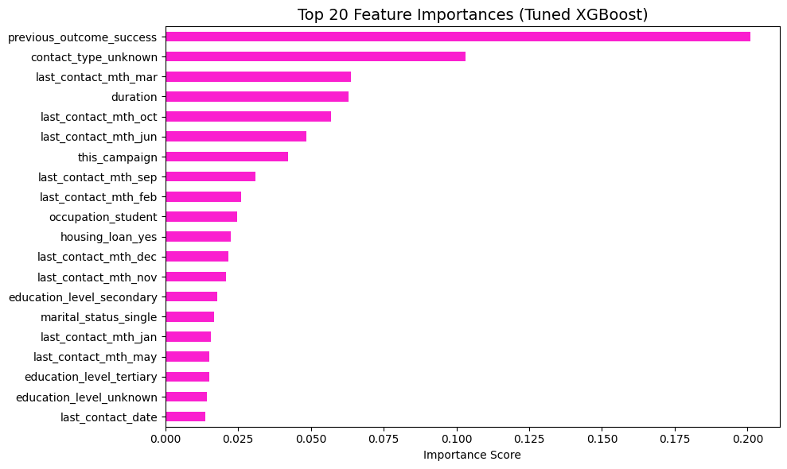
Observations:
- XGBoost and ANN are the top performers.
- XGBoost gives the best balance in AUC and F1 — ideal when ranking customers by subscription probability.
- XGBoost had the best results. for deployment based on overall performance. Excellent at ranking and classifying positive cases. Performs very well on imbalanced data.

Business Insights & Recommendations

Prioritize Call Quality Over Quantity
- Insight: Longer, more meaningful calls are stronger predictors of subscription than frequent, shorter contacts.
- Action: Improve subscription rates by prioritizing high-quality, personalized calls over frequent contact. Train agents to engage meaningfully, set optimal contact limits (2–4 calls), and use CRM automation to prevent over-contacting and customer fatigue.

Retarget Past Converters
- Insight: Clients who have previously responded positively to campaigns are significantly more likely to subscribe again.
- Action: Retarget past converters with personalized messaging and prioritized follow-ups to boost conversions. Tag experienced responders and apply a cooling period before re-engagement to maintain effectiveness.

Time Campaigns Strategically
- Insight: Engagement is highest during specific months, such as May, indicating seasonality in client response.
- Action: Time campaigns effectively by focusing on peak months. Allocate more resources and focus on campaigns during high-conversion periods, such as peak months, while reducing outreach during off-peak months to avoid over-contacting and subscriber fatigue.

Focus on High-Balance Clients
- Insight: Clients with higher yearly balances are more likely to subscribe to term deposits.
- Action: Concentrate campaign efforts and budget during high-conversion months like May, prioritizing mobile-friendly channels. Reduce outreach during off-peak periods to prevent over-contacting and maintain customer goodwill.

Enhance Data Collection
- Insight: Missing or “unknown” values in key data points such as education level and contact type reduce the model's predictive accuracy and could limit targeted marketing efforts.
- Action: Improve data collection and tracking to reduce missing values and ensure cleaner, more consistent data. This enhances model accuracy, enables better personalization, and supports more effective campaign targeting.

Align Messaging with Client Segments
- Insight: Occupation and education influence preferences.
- Action: Customize messaging based on client profiles — focus on investment growth for managers, security for blue-collar workers, and financial stability for homeowners — using an education–occupation messaging strategy.

Dashboard Deployment
- Purpose
The interactive dashboard serves as a practical decision-support tool for marketing teams, streamlining and enhancing campaign execution. It bridges the gap between machine learning insights and business application through an accessible, no-code interface.
- Predict the likelihood of clients subscribing to term deposits using a trained XGBoost model.
- Support strategic campaign planning and lead targeting.
- Bridge the gap between technical model output and business decision-making.
- Key Benefits
- Faster Decision-Making: Automates prediction workflows, significantly reducing the time spent on manual evaluation and segmentation.
- Empowered Self-Service: Enables marketing personnel to independently generate insights and predictions without relying on technical teams.
- Improved Campaign ROI: Directs resources toward high-likelihood clients, while reducing effort spent on low-conversion prospects.
- Data Transparency: Provides visual insights into feature importance, ensuring consistent and explainable decision-making processes.
- Scalability and Flexibility: Accommodates both individual and batch predictions through single input fields or CSV file uploads, supporting diverse campaign planning needs.
- Functionalities
- Feature Importance Tab
- Visualizes the top 20 features that influence model predictions.
- Helps users understand which inputs (such as call duration, balance, or prior campaign success) contribute most to subscription decisions.
(See figure 7: Fig7FeatureImportanceTab.png)
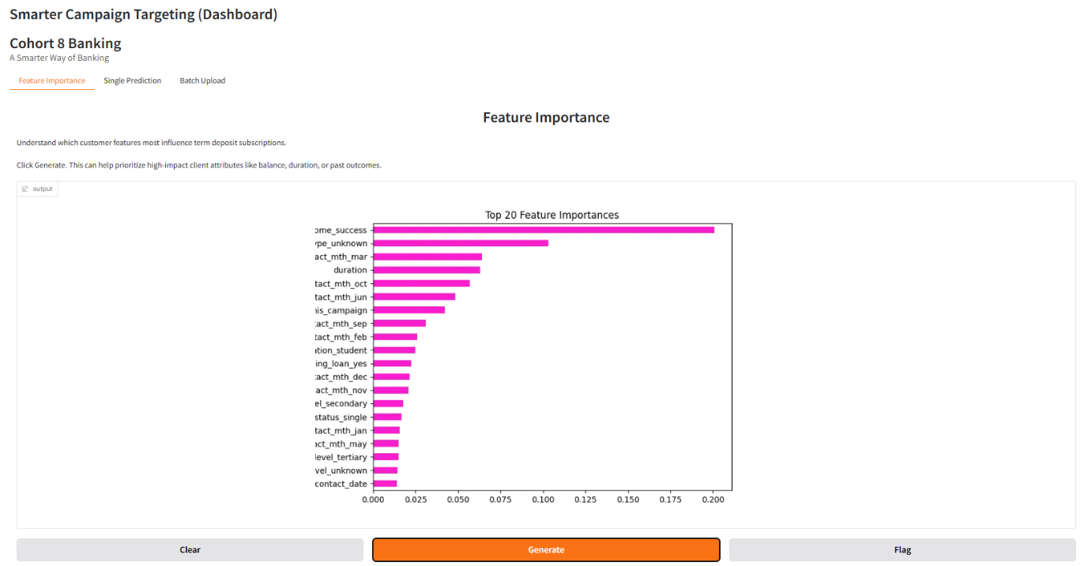
- Single Prediction Tab
- Allows users to manually enter a client’s information and receive a prediction with a confidence score.
- Useful for reviewing individual clients or simulating different scenarios.
- (See figure 8: Fig8SinglePredict.png)
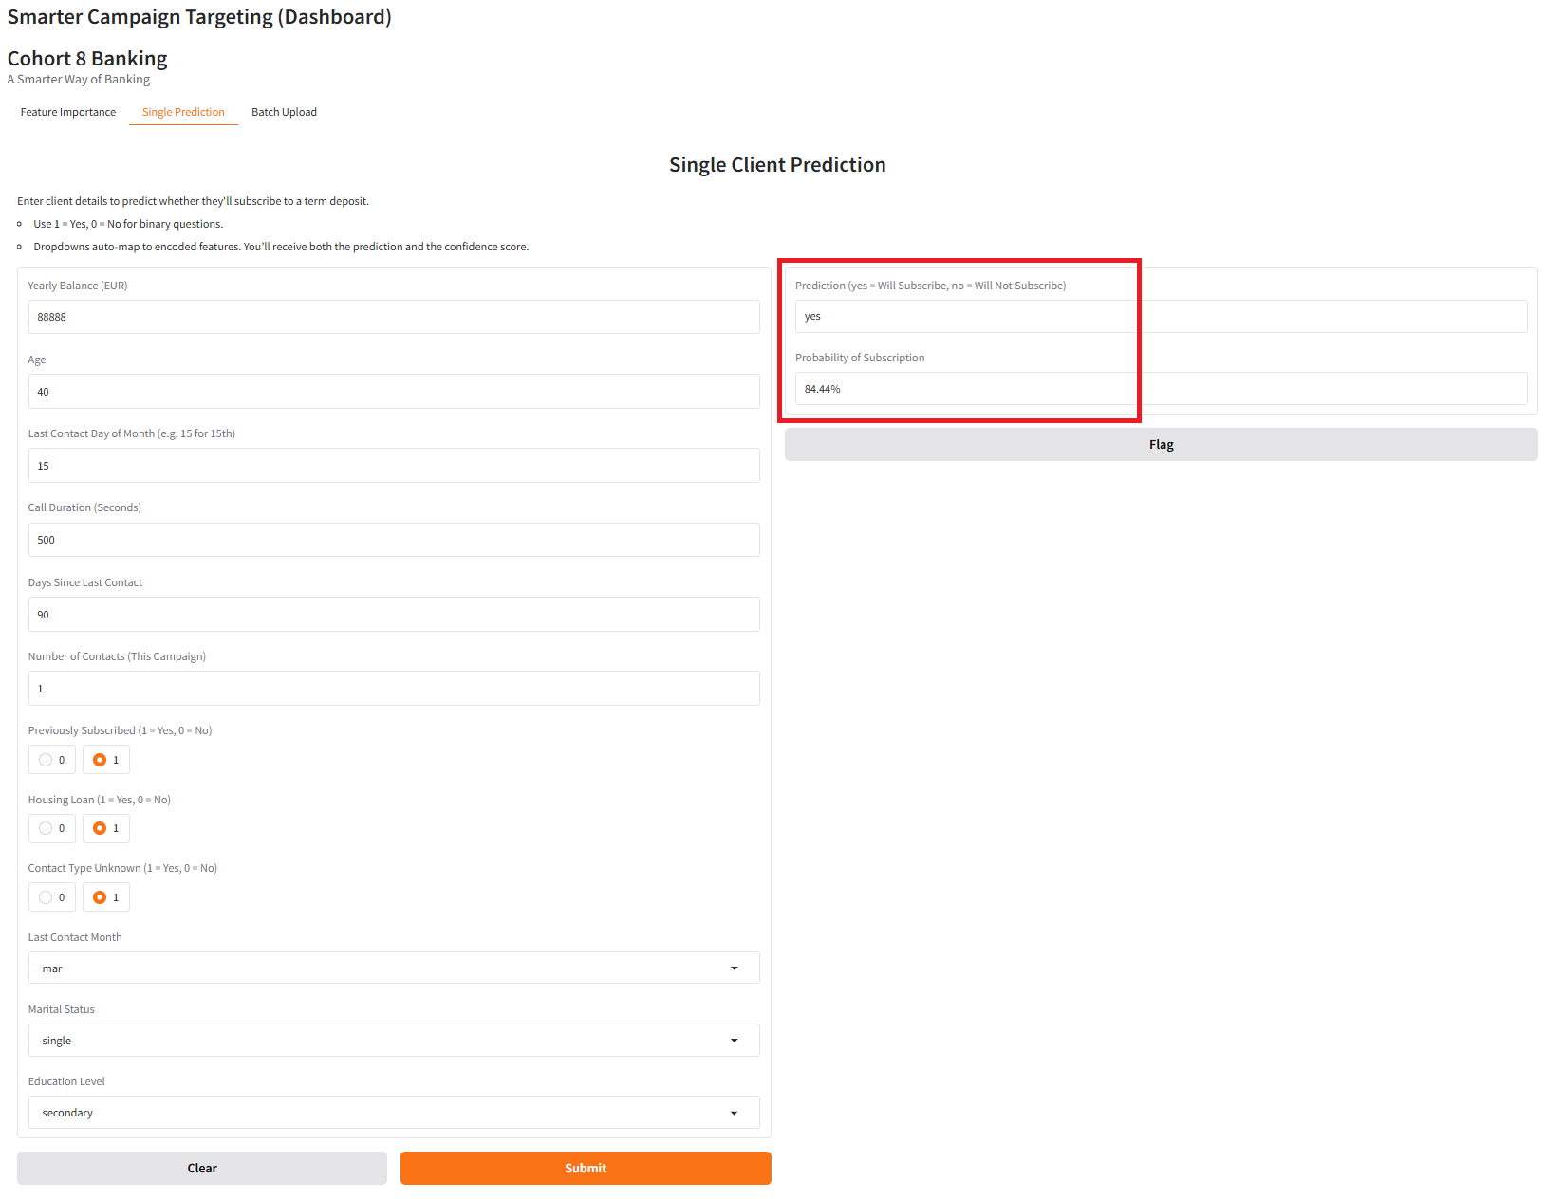
- Batch Upload Tab
- Accepts a CSV file with multiple client records.
- Returns predictions and probabilities in a downloadable format for batch analysis.
- (See figure 8: Fig8SinglePredict.png)
- (For the blank template see appendix D. (file: appendix D blank_template.csv)
- (For sample template see appendix E. (file: appendix E samples.csv)
(For a sample of predicted output see appendix F (file: appendix F predicted_output.csv)
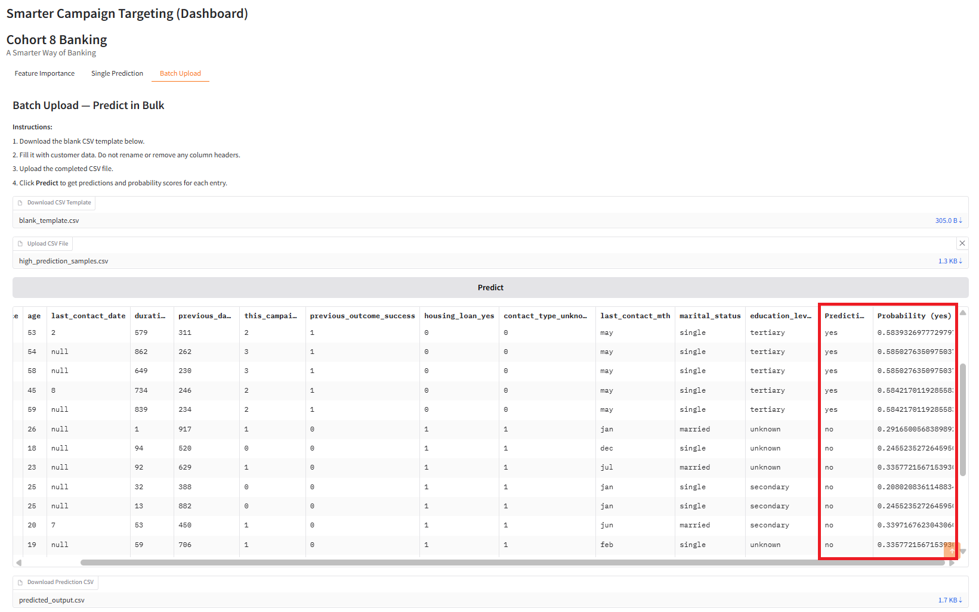

Challenges: Failure of Dashboard
Improving Prediction Accuracy Through Better Input Features
- Initial Issue:
Early dashboard inputs prioritized user convenience (e.g., balance, loan status), but these low-impact features led to consistently low-confidence “no” predictions.
- Problem Identified:
Predictions remained negative with probability < 0.3 because the input features did not reflect those most influential to the model.
- Refinement:
Replaced low-impact inputs with high-impact ones based on feature importance analysis:
  - Marital status
  - Education level
  - Month of last contact
  - Call duration
- Outcome:
Predictions became more realistic, with probabilities > 0.5 and positive (“yes”) results emerging. The dashboard became more accurate, useful, and actionable.
- Key Insight:
Effective dashboards must align user input fields with the model’s most predictive features—not just user-friendly ones.

Conclusion
- This project successfully delivered a machine learning system to support Cohort 8 Banking's marketing efforts. Using past campaign data, the XGBoost model achieved strong performance (90% accuracy and 92.3% ROC AUC), even with imbalanced classes. The findings clearly show that call quality, prior campaign success, timing, and client wealth are strong predictors of subscriptions.
- The deployment of an easy-to-use dashboard gives non-technical staff the ability to run single or bulk predictions and visualize what influences client decisions. This ensures the model’s insights can be put into action. This project strengthens data-driven decision making, helps reduce marketing waste, and gives the team a practical tool for future campaigns

Appendix
- Data Dictionary
The data is related with direct marketing campaigns of a Portuguese banking institution. The marketing campaigns were based on phone calls. Often, more than one contact to the same client was required, in order to access if the product (bank term deposit) would be ('yes') or not ('no') subscribed.
This research focus on targeting through telemarketing phone calls to sell long-term deposits. Within a campaign, the human agents execute phone calls to a list of clients to sell the deposit (outbound). This study considers real data collected from a Portuguese retail bank, from May 2008 to June 2013, in a…
- Cite: Moro, S., Rita, P., & Cortez, P. (2014). Bank Marketing [Dataset]. UCI Machine Learning Repository. https://doi.org/10.24432/C5K306.
- Dataset used named as: bank-full.csv
- With 45,211 entries with 17 columns that that have int64(5 columns) and object( 11 columns)
Feature | Description | Data Type | Values / Range
age | Age of the client | Integer | 18 – 95
occupation (job) | Type of job | Object | 'admin.', 'blue-collar', 'entrepreneur', 'housemaid', 'management', 'retired', 'self-employed', 'services', 'student', 'technician', 'unemployed', 'unknown'
marital_status | Marital status | Object | 'divorced', 'married', 'single' (Note: 'divorced' includes widowed)
education_level | Education level | Object | 'unknown', 'secondary', 'primary', 'tertiary'
credit_default | Has credit in default | Object | 'yes', 'no'
yearly_balance | Average yearly balance (in euros) | Numeric | -8019 – 102217
housing_loan | Has housing loan | Object | 'yes', 'no'
personal_loan | Has personal loan | Object | 'yes', 'no'
contact_type | Contact communication type | Object | 'cellular', 'telephone', 'unknown'
last_contact_date | Last contact day of the month | Integer | 1 – 31
last_contact_mth | Last contact month | Object | 'jan', 'feb', 'mar', ..., 'dec'
duration | Last contact duration in seconds | Integer | 0 – 4918
this_campaign | Number of contacts during this campaign | Integer | 1 – 63
previous_days (pdays) | Days since last contact from previous campaign | Integer | -1 (not contacted before) to 871
previous_campaign | Number of contacts before this campaign | Integer | 0 – 275
previous_outcome | Outcome of the previous marketing campaign | Object | 'failure', 'nonexistent', 'success', 'others'
term_deposit | Target variable: whether client subscribed to a term deposit | Object | 'yes', 'no'
- Modeling Results
Full results of four models: see file: appendix b ModelingResults.xlsx)

- Evaluation Metrics Explained
Explanation of each of these classification evaluation metric
Metric | What It Measures | Why It Matters
Accuracy | The proportion of correct predictions out of all predictions. | Useful when the classes are balanced (e.g., 50/50 yes-no), but can be misleading with imbalanced data.
Precision | Out of all predicted "yes" (positive), how many were actually "yes".  Formula: TP / (TP + FP) | Tells you how accurate your positive predictions are. High precision = few false alarms.
Recall (Sensitivity) | Out of all actual "yes", how many did we correctly identify?  Formula: TP / (TP + FN) | Measures how well your model captures actual positives. High recall = few misses.
F1 Score | The harmonic mean of Precision and Recall.  Formula: 2 * (Precision * Recall) / (Precision + Recall) | Balances precision and recall – especially important when classes are imbalanced (like in your case).
ROC AUC Score | Measures how well the model separates classes across all thresholds. Ranges from 0.5 (random guessing) to 1.0 (perfect). | Gives a broader view of performance. AUC = area under the ROC curve. Higher = better separation.
Support | The number of actual samples in each class (e.g., how many "yes", how many "no"). | Helps interpret the other metrics in context.

- Class imbalance: Only ~12% of customers subscribed.
- Accuracy may be misleading alone (you could get 88% accuracy by always predicting "no").
- F1 Score helps you evaluate how well the model balances false positives and false negatives.
- ROC AUC shows how well your model can distinguish between "yes" and "no" across different thresholds.

- Dashboard Batch Upload Template
for the blank template see appendix D. (file: appendix D blank_template.csv)
- Sample Upload Template
for the blank template see appendix E. (file: appendix E samples.csv
- Sample of Predicted output
for a sample of predicted output see appendix F (file: appendix F predicted_output.csv

- Step-by-Step Guide
Step-by-Step Guide to Run the Smarter Campaign Targeting Dashboard

